smart animal farm using IOT

# 1.INTRODUCTION

## 1.1 OVERVIEW:

Smart animal farm is a progressive technology that has been developing the present era,infact adopting to the modern technologies makes the human existence easier and more reliable .the constant monitoring with the sensor make the work perfectly than doing that by humans.

reasons of implementing iot in animal farm

More number of people required in order to monitor the farm.

There may be a delay in providing water and fooder to the farm

People might not aware of the situation in the form at all the places.

Any problems arises it took a lot of time to rectify where it happened.

## 1.2 Purpose:

As there is increase in the population ,there is a need to have good environment inorder to produce good products these things can only happened we adopt new technology and make the things more accurate , well structured .

# 2 LITERATURE SURVEY

## 2.1 Existing problem:

**The problems that are existing in natural animal farm are:**

* **There is no proper utilization of natural resources like electricity and water .**
* **The internal environment is not able to identified by the people what are the gases it filled with ,humidity levels which can cause harm to the animals .**
* **If there is any fire accidents in the form it is not immediately rectified .**

## 2.2 proposed solution:

Through Smart animal IOT ,web app and as well as mobile application we can monitor the internal environment of the farm such as Temperature ,Humidity ,water level of the tank ,NH3 values ,FIRE alert .

We can automate the exhaust fans when the temperature exceeds the limit

Also we can operate lights ,water pump ,exhaust fans form the mobile and web application as a result the resources are utilized properly .

# 3 THEORITICAL ANALYSIS:

## 3.1 Block diagram:

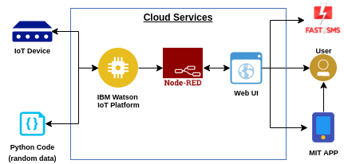

# The input is taken form esp32 module and python code ,those values are given to the ibm iot platform ,then the values are fetched by the node red service there after we send them to cloud db and web ui and mobile ui to display to the user.

# 3.2 Hardware / Software designing:

At first we need to install Arduino software in the system , then we need to import ESP32 dev module ,then we need to set the ports of board ,we need to connect ESP32 to the along with the sensor to the board .

We need to create an IBM account in that we need to subscribe the Internet of the things (iot in ibm platform),we need to generate the device credentials ,like device id,type ,key ,authentication token,which are further used in the project to send the values to the iot platform.

**Application Building:**

* we need to build a node red service in ibm iot platform
* by installing the libraries to the node red service we further use them for applications
* we need to obtain the data form esp32 and send it to the cloud.
* then we need to build a web ui and mobile application using mit app inventor

**Running the code:**

* we need to develop a code in arduino for sending data to ibm iot platform .
* also we need to develop a python code to send the data.
* we need to fetch form both ends and configure it with the nodes in the node red .
* by using cloudant db nodes we need to send the data to the cloud.
* by integrating the message alerts using fast to sms we can alert the user in case of fire or nh3 excess accidents.

IBM deployment:

1. As we are able to fetch the values on esp32 we can send that data to ibm iot using mqtt protocol
2. By connecting to the local wi fi server the values are directly sent to ibm iot .
3. After successful deployment of the values of the sensors we can see a massage on the serial monitor
4. In python code we first install wiotp-sdk which can connet with the ibm platfom using device credentials.

# 4 EXPERIMENTAL INVESTIGATIONS:

As our project is small usage of iot sensors we cannot provide fully automated smart animal form we can provide ,some applications ,like view of internal enviroment of farm and able to control lights ,pump,exhaust, using web and mobile application

# 5 FLOWCHART:

Import libraries

For ardiuno

Sending the values

To ibm iot

Sending the data to

Cloud platform

Making a web ui

Interface to display

And control

Building a mobile

Appliction

Configuring fast2sms

Controlling the application

Integrating all services

With ibm iot

# 6 RESULT:

.

**Ardiunocode:**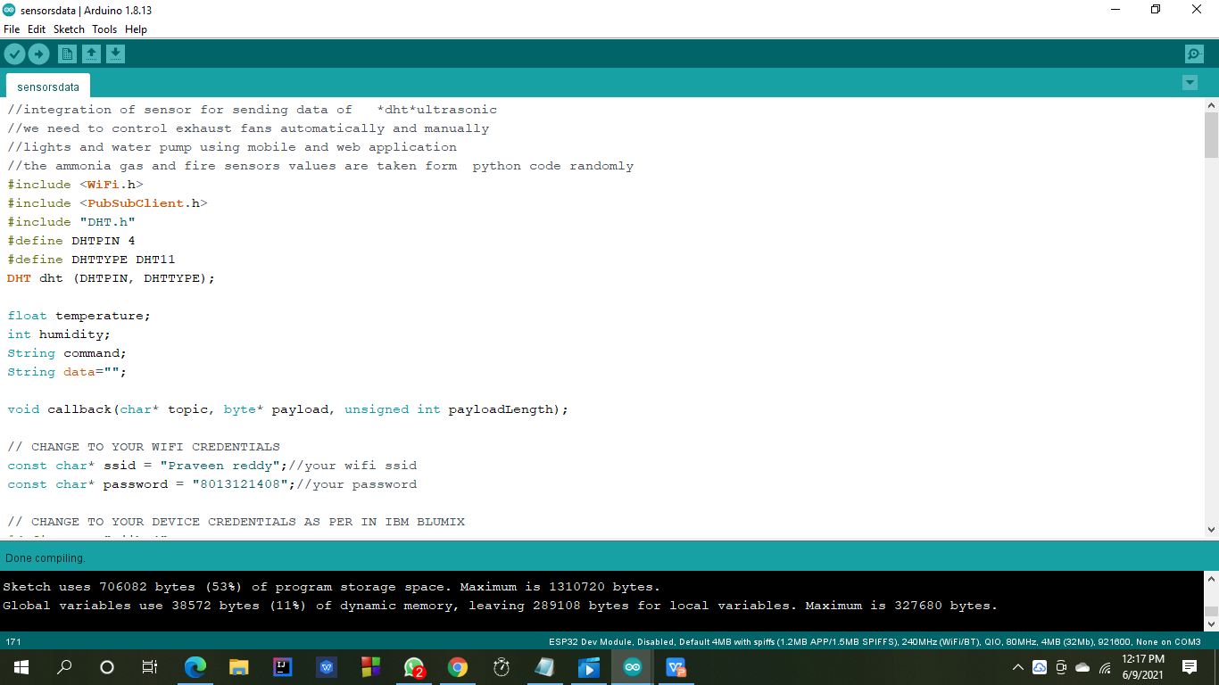

**Ibm iot :**

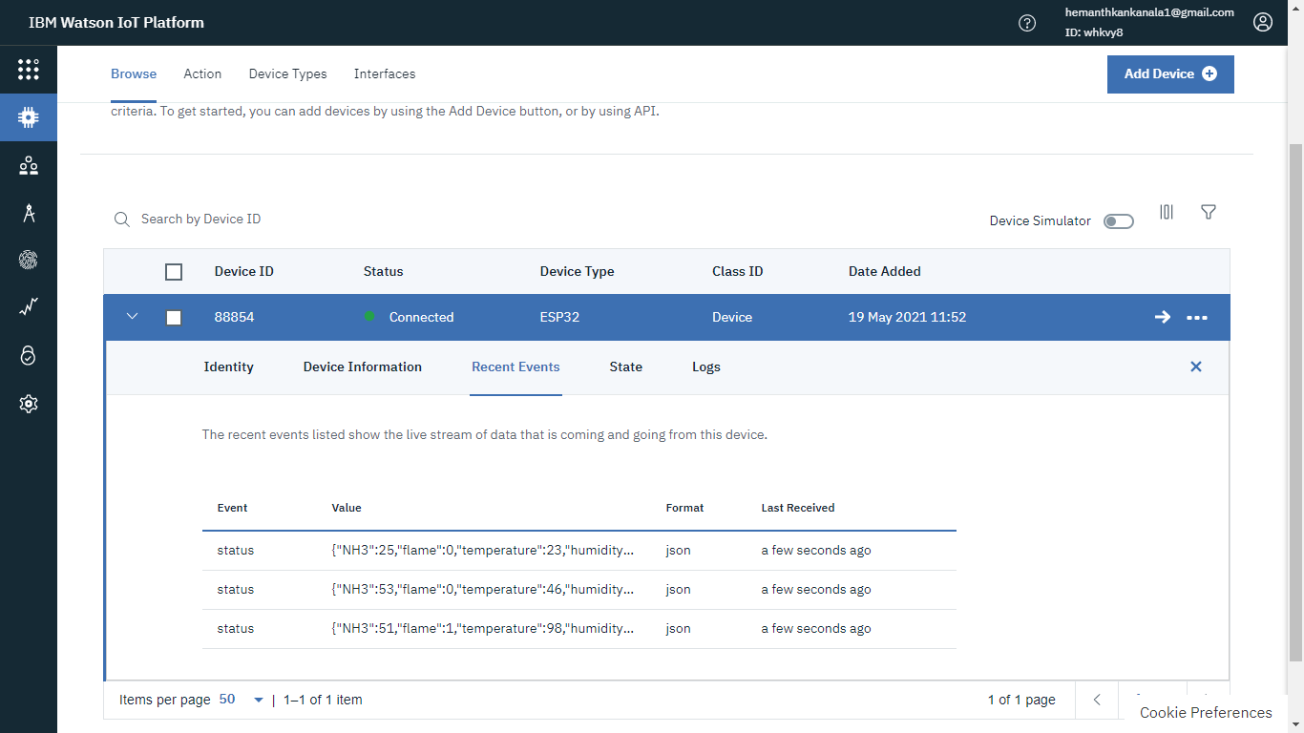

**Values on the serial monitor**

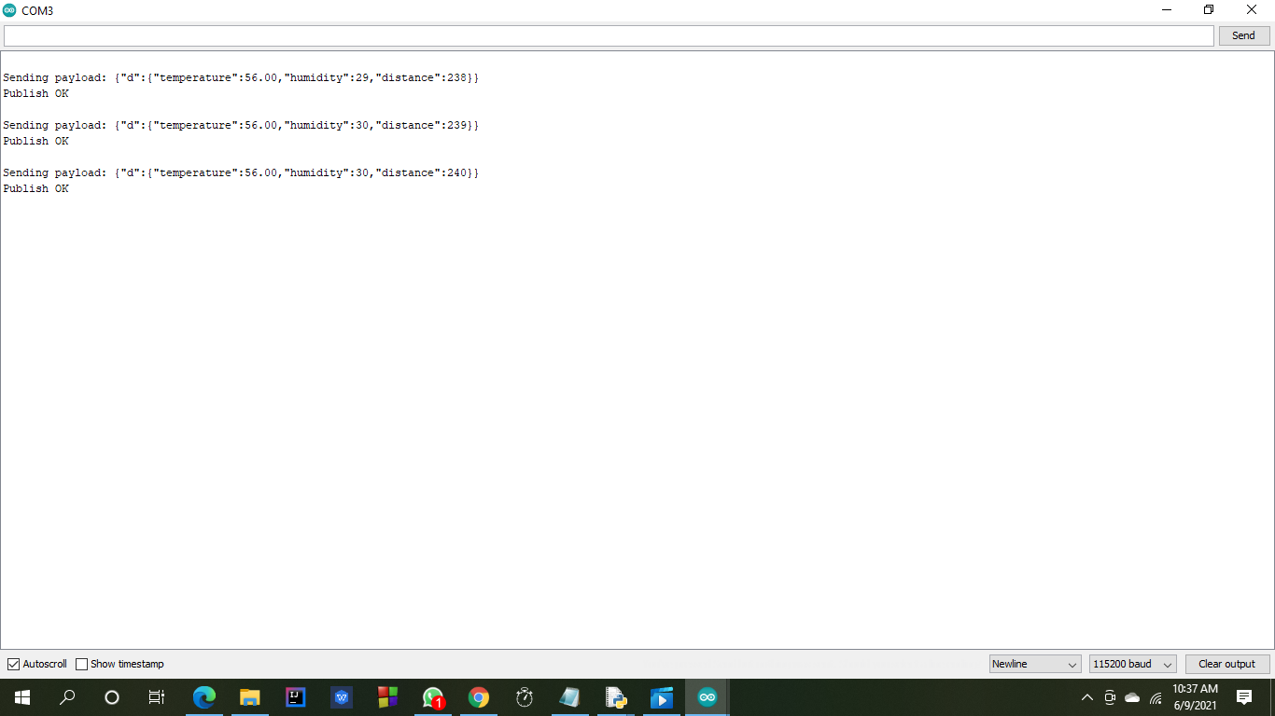

**Node red service:**

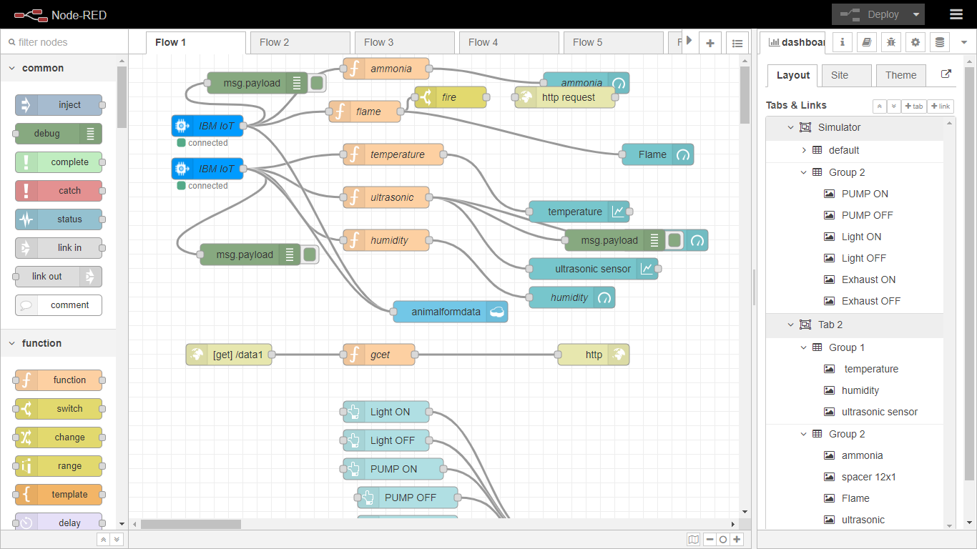

1. 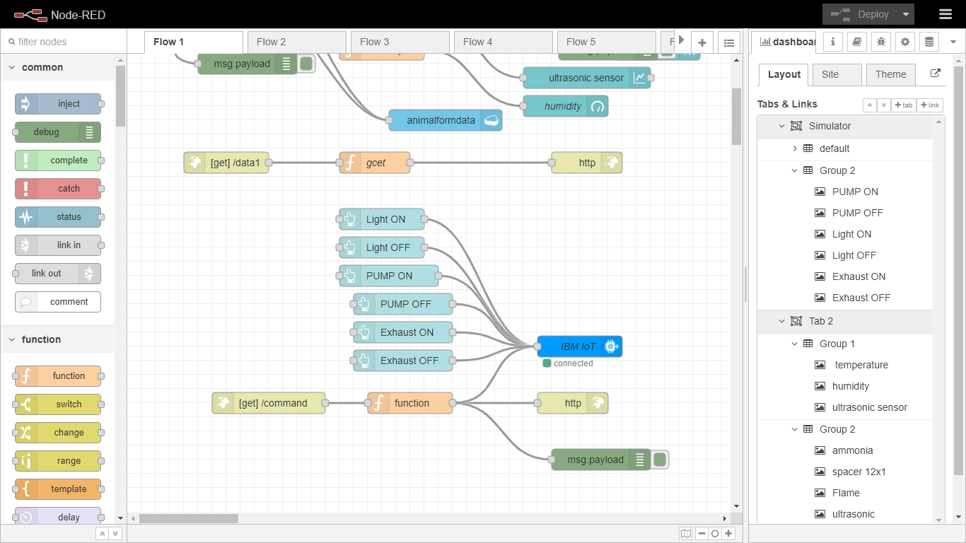
2. **Cloudant db**
3. 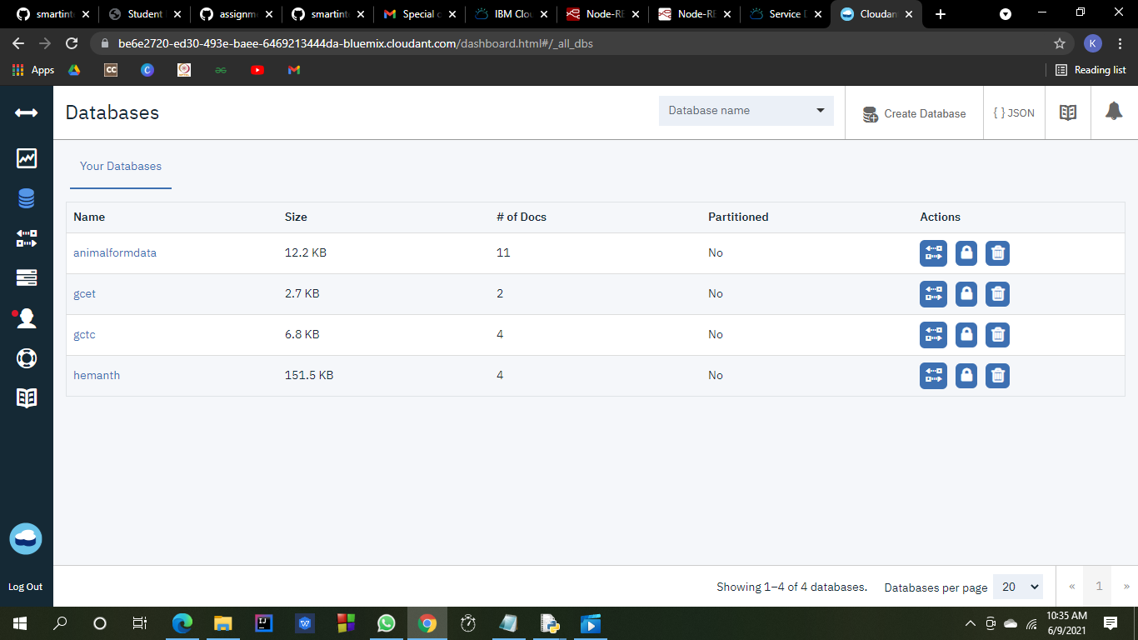

**4.** 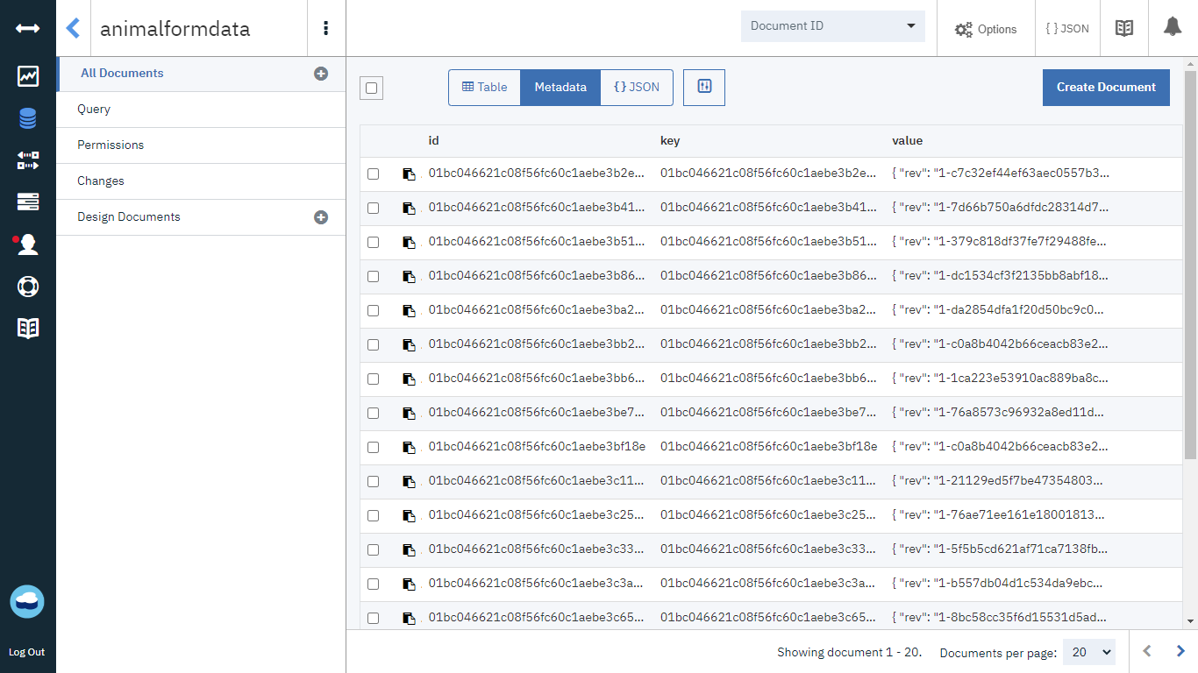

**5.** web ui

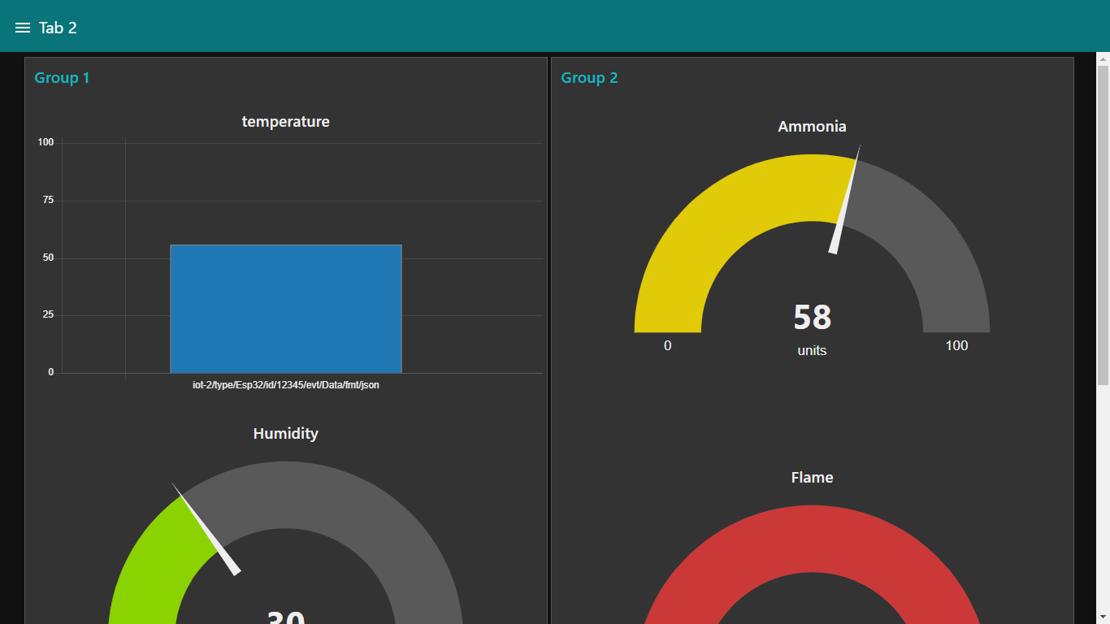

**Web ui**

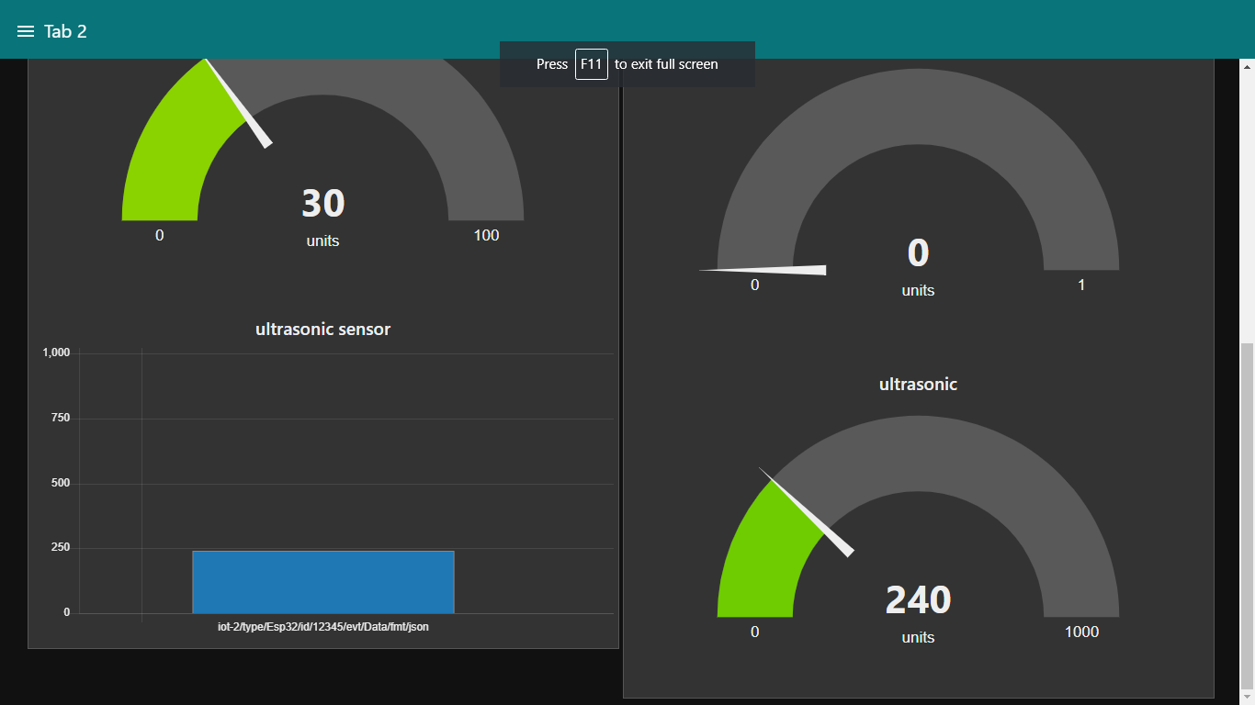

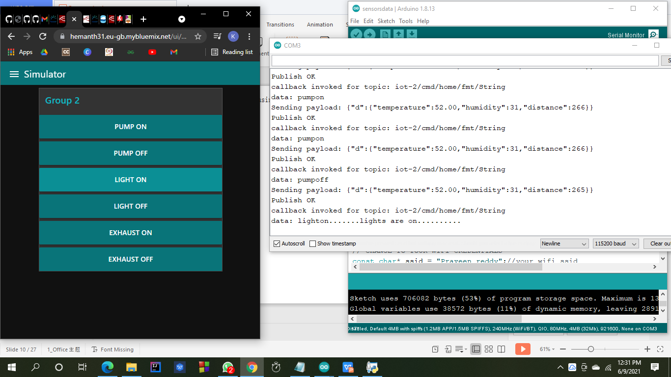

**Mobile appliacation using mit app inventor:**

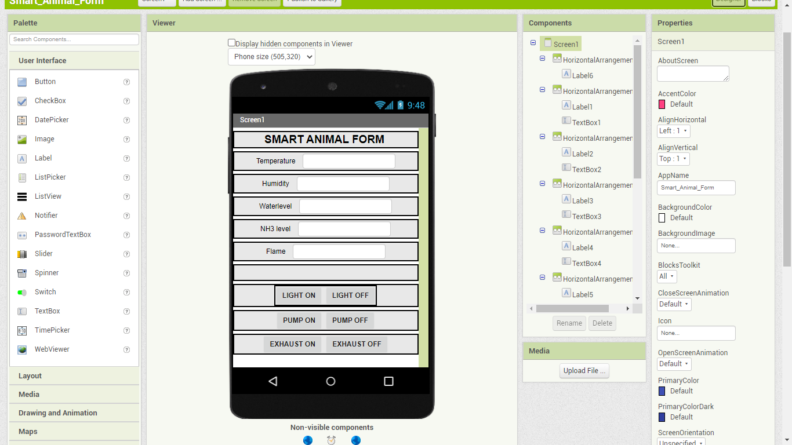

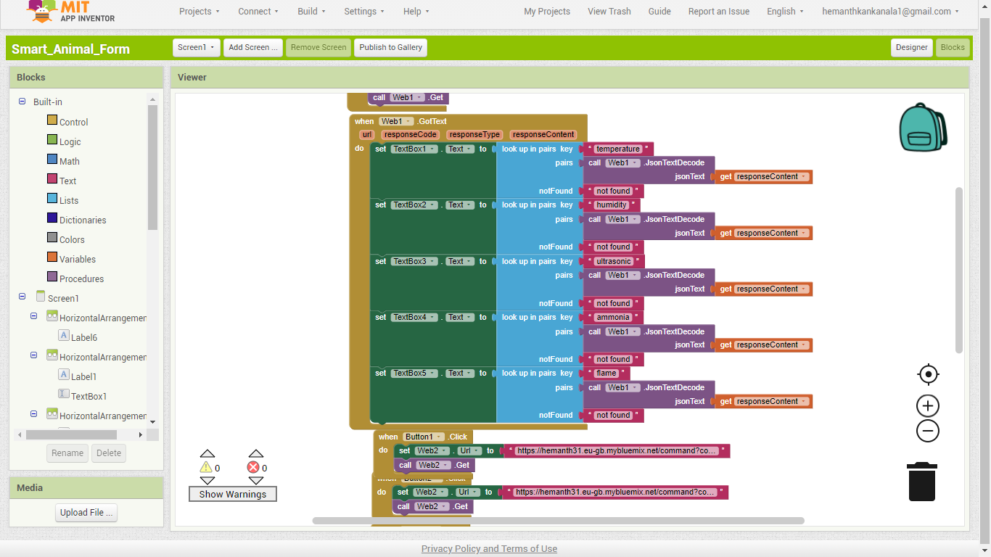

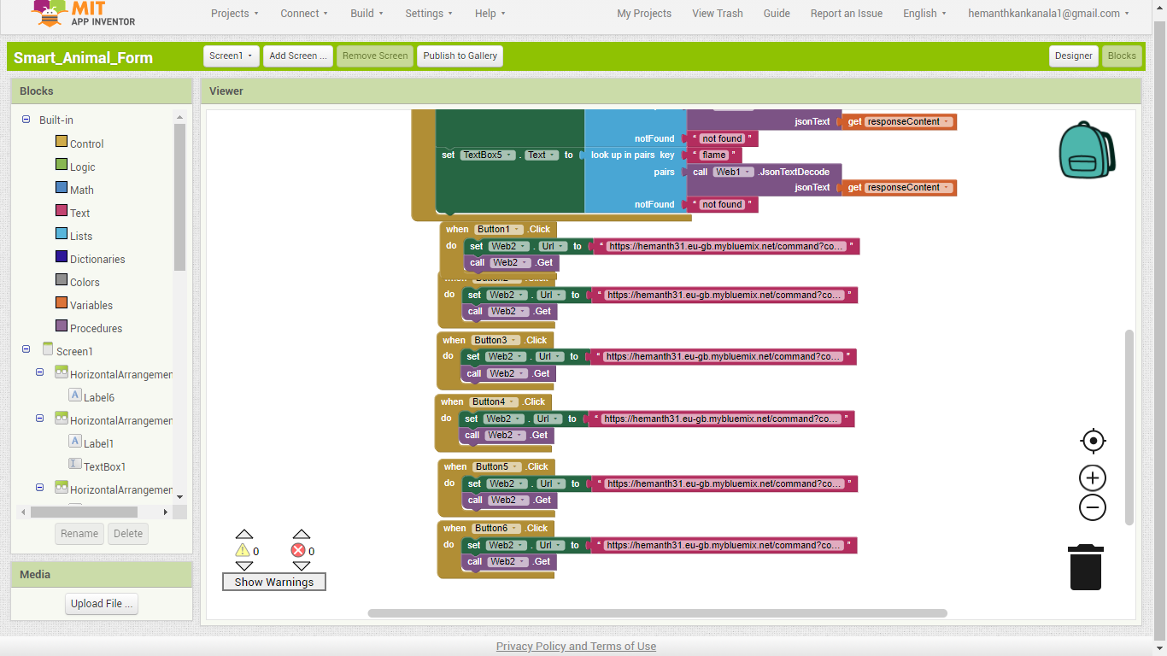

**Fast 2 sms service:**

# Screenshot (307)

Python code random values:

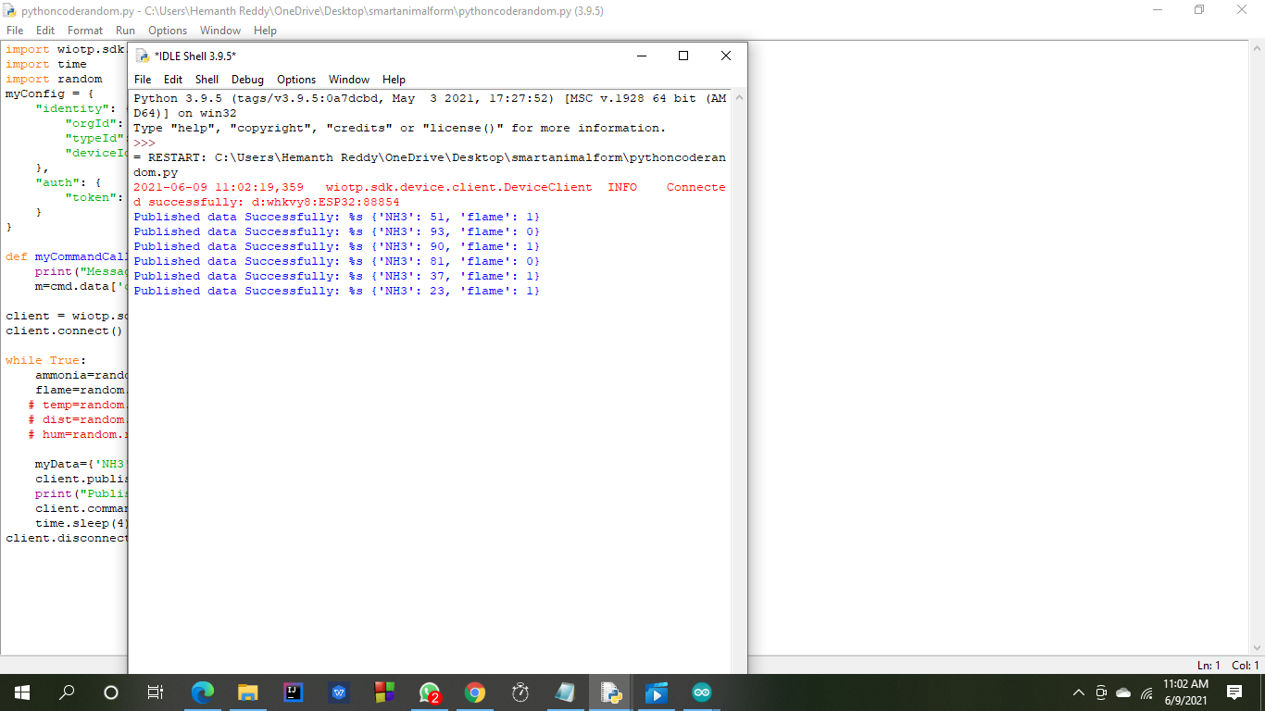

# RESULT:

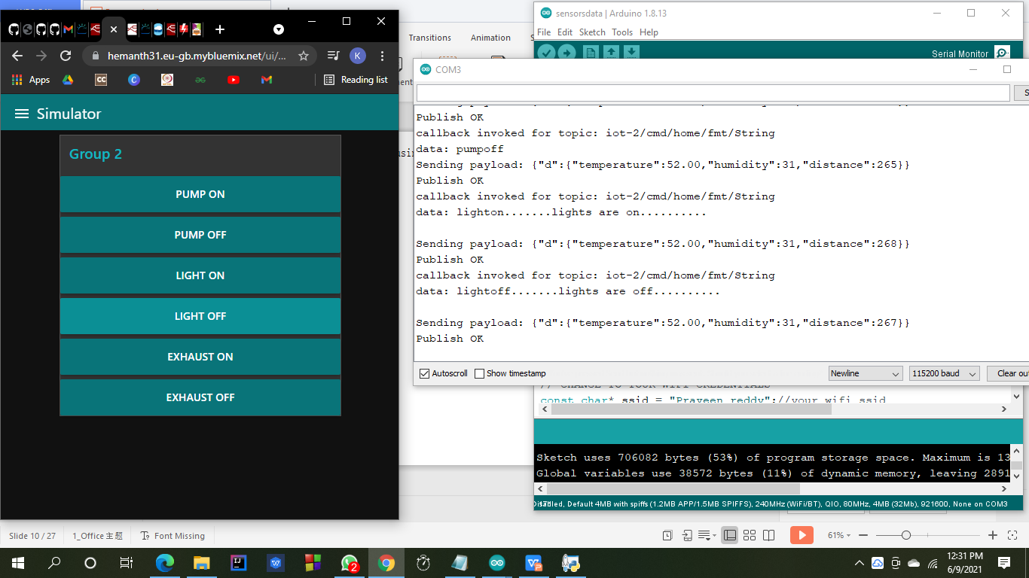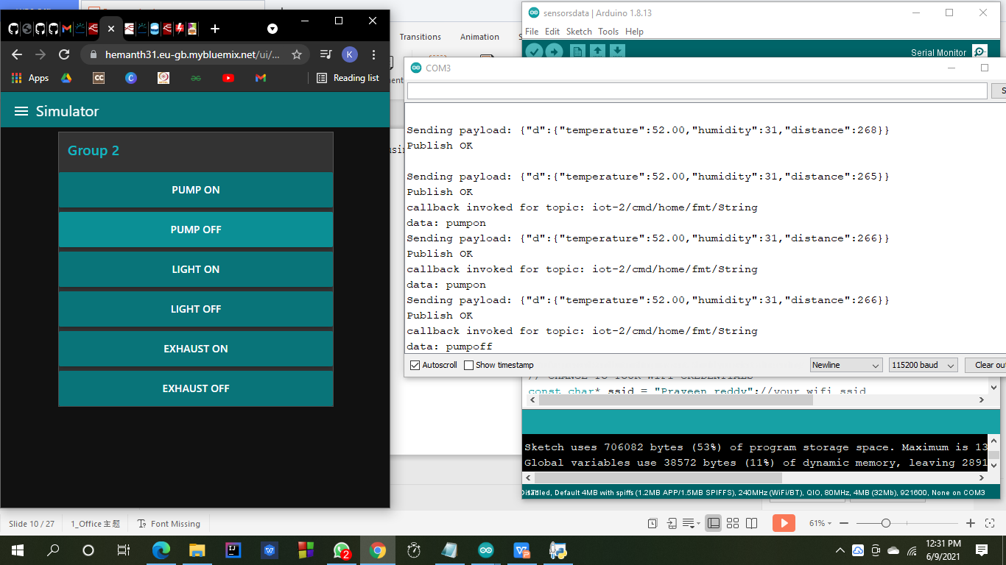

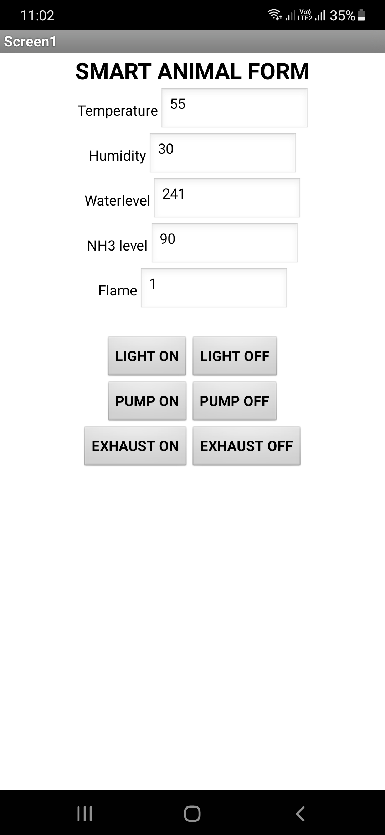

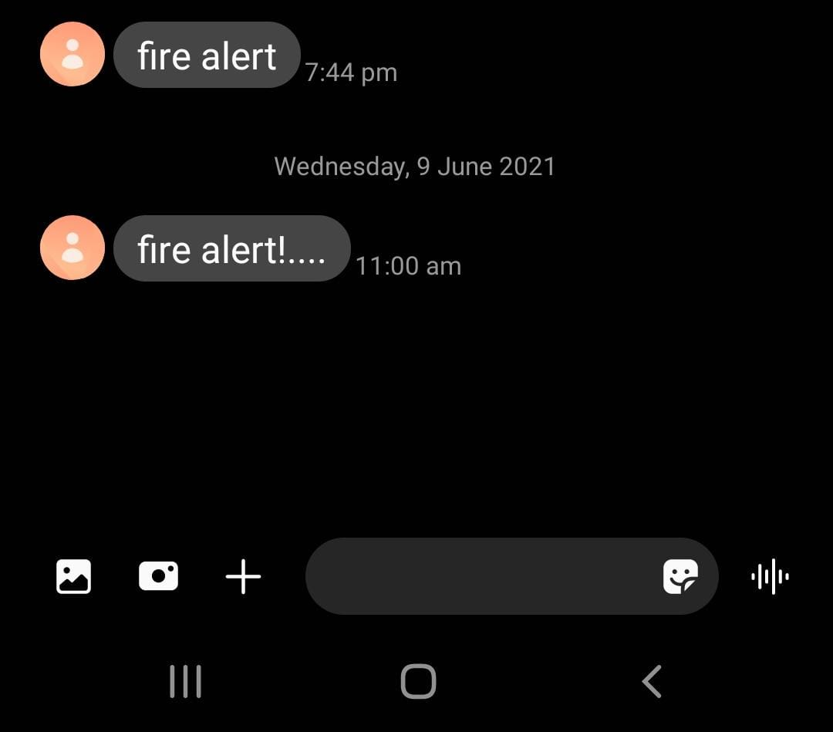

# 7 ADVANTAGES & DISADVANTAGES:

## 7.1 ADVANTAGES:

1. User can easily control the things form any where in the world using internet.
2. It becomes easy to identify in case of fire accidents.
3. We can utilize the resources properly
4. The animals can get food and water in time.
5. No need of huge human efforts .

## **DISADVANTAGES:**

1. As it need internet in case of failure of devices it will not work properly.
2. It will not work in remote areas where internet is not available.

# APPLICATIONS:

* It is so useful in large farms where we cannot go and observe all the area.
* It is useful for poultry because it has large area.

# CONCLUSION :

We have build an web application and mobile application as well in order to control and monitor the farm which reduces much human efforts in these applications.

# FUTURE SCOPE:

1. This smart animal farm is helpful for the people who have large area to monitor and control .
2. As compared to human it can monitor and control accurately .it is preffered as the first choice in this industry.
3. Production of food also increases as we have increased the environment quality.
4. The speed of the serving increases the health of the animals in the farm as a result future prefer smart animal farm.

# BIBILOGRAPHY:

Dataset and code reference given by -- <https://smartinternz.com/>

IBM Cloud -- <https://cloud.ibm.com/login>

HTML background images – <https://www.google.com/>

Theory reference – <https://www.google.com/>